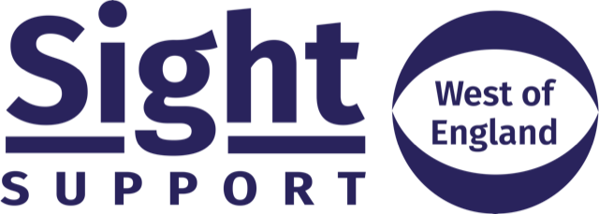

Job Description
Community Sight Loss Advisor (Bristol, Bath, South Gloucs)
Salary: £21,420 (F-T equivalent)
Hours of work: 21 hours part-time (0.6 FTE)
Location: Bristol
Direct Reports: Volunteers
Contract status: Permanent after satisfactory probationary period
Annual Leave: 25 days plus bank holidays (Pro Rata)
Organisation Details:
Sight Support West of England exists to reduce the impact of sight loss, supporting blind and partially sighted people to lead independent lives and to secure equal access to services.
As a Community Sight Loss Advisor, you will play a lead role in providing our Information, Advice and Guidance Service for people living with sight loss across Bristol, Bath and South Gloucestershire. You will assess the needs of people with sight loss and prepare appropriate action plans to ensure that they are accessing support, equipment and training to help them adjust to their sight loss.
You will work alongside the Community Sight Loss Advisor Manager to plan and organise community hubs in key locations in the geographical area of benefit.
Responsibilities:
- Provide information, advice and guidance to blind and partially-sighted people using Sight Support West of England’s services, including the provision of support with equipment and training to help clients adjust to their sight loss.
- Conduct one-to-one Sight Loss Assessments and prepare action plans for clients.
- Signpost and/or refer clients to other services and agencies where relevant.
- Plan and organise Sight Loss Advice drop-in surgeries in key locations across the Bristol, Bath, South Gloucs area.
- Support the recruitment and management of a team of volunteers who will offer support to clients to improve their independence and wellbeing.
- Encourage clients to access Eye Health and Sight Loss Services such as High Street Optometry, Hospital Eye Units and Low Vision Clinics.
- Liaise closely with the local rehabilitation teams, Eye Clinic Liaison Officers and other agencies as necessary.
- Develop peer support in the local community by supporting social groups for the visually impaired.
- Conduct home visits to clients where they are unable to access services otherwise
- Work with the Administration & Communications Officer to ensure social groups, community hubs and other events (including those being delivered by partner agencies) are advertised promptly on our website and social media
- Ensure that Sight Support marketing material is available in opticians, eye clinics, GP surgeries and other appropriate places in your geographic area
- Proactively seek other opportunities to promote services to new audiences at a local level (e.g. parish magazines)

Person Specification
 | Essential | Desirable
Experience & Qualifications | Educated to GCSE level English and Maths or equivalent.  Providing information, advice & guidance.  Working in a caring profession. | Experience of working with people with disabilities.  Experience of working with volunteers.  Experience in using an assessment framework.
Knowledge & understanding |  | Knowledge of the Bristol, Bath, South Gloucs area.  Understanding of the needs of people with sight loss.  A knowledge of local and national service provision for blind and partially sighted people.  Knowledge and understanding of the use of Assistive Technology.  Knowledge of disability issues.
Skills & abilities | Ability to manage a diverse caseload and deal with complex enquiries.  Ability to communicate effectively, including listening and empathising.  Ability to identify client needs and translate them into achievable goals.  Ability to develop and maintain appropriate and positive relationships with clients and outside agencies.  Ability to support and motivate a team of volunteers.  Ability to respond imaginatively and flexibly to client needs and to solve problems.  Well organised with an appreciation of the importance of forward planning and working to deadlines.  Ability to work on own initiative and liaise with Line Manager as and when required.  IT literate - competent and confident in use of Microsoft Office software  and case management systems.
Personal qualities & competencies | Self-motivated.  Able to work on their own but also as part of a wider team.  Personal commitment to equal opportunities & anti-discriminatory practice.  Able to respond to callers and visitors in a professional and friendly manner at the same time – this includes spoken and written communication.  A commitment to empowerment.  Ability to travel around the area to meet with clients and volunteers.
Sight Support is committed to quality, equality and valuing diversity, and welcome applications from all backgrounds. As a sight loss charity, we particularly encourage applicants who are visually impaired to apply.
Please note
- This post is subject to a DBS check.
- Full training and ongoing professional development will be offered to the right candidate.
If you would like to know more about the role before you apply, informal confidential discussions prior to application are welcome; please call 0117 322 4885 to arrange an appointment.
To apply for this post please send a CV and a covering letter outlining your suitability for the post to info@sightsupportwest.org.uk. Please title your email ‘Application for Community Sight Loss Advisor (Bristol)’.

