

Community Sight Loss Service

Helping people adapt to sight loss and remain independent
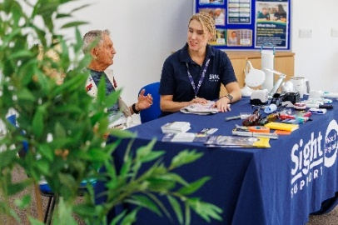
Why our support matters
Changes in sight can affect many aspects of everyday life, from reading correspondence and preparing meals to getting out and about. People's experiences vary, but some may face new practical challenges or uncertainty about the future, particularly following a diagnosis. Access to specialist advice and practical support can help people find solutions that work for them.
More than 3,900 people in our region are blind or partially sighted, and nearly 400 people are newly diagnosed each year. Demand for our support is increasing, with referrals rising by 25% in 2025.
Without timely, accessible support, people can struggle to maintain their independence and may become increasingly reliant on family, friends or statutory services.
How we help
25% increase in referrals in 2025
Sight Support West of England provides free, specialist advice and practical support to blind and partially sighted people across Bristol, Bath and North East Somerset, and South Gloucestershire.
Our Community Sight Loss Advisors work with people to understand their individual needs and find practical solutions to everyday challenges. Support includes advice on magnification, lighting, daily living equipment, accessing benefits, mobility and communication, alongside emotional support and referrals to other services.
Through our 17 Community Sight Loss Hubs, appointments at our Resource Centre and volunteer-supported social groups, people can access help locally and return whenever their needs change.
Our aim is to help blind and partially sighted people find practical solutions, make their own choices and continue doing the things that matter to them.
Our reach and impact
1,800 people registered for our services
3,646 advice sessions delivered in the past year
17 community hubs providing local access to support
91% made progress in at least one key outcome area
96% felt better able to cope with daily life following our support
96% of those experiencing isolation felt less isolated after receiving support
The difference it makes
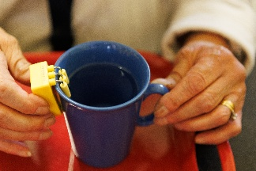
One man came to us looking for help to continue reading his newspaper. During his appointment, he also discovered a liquid level indicator, which enabled him to safely make his wife a cup of tea again — something he had done every morning for more than 50 years.
For him, this small piece of equipment meant much more than making a drink. It gave him a practical way to continue a daily routine that was important to him.
Funding our Community Sight Loss Service
Providing support when it matters most
Our Community Sight Loss Service provides early intervention following diagnosis and ongoing support as people's needs change. Our local hubs and Resource Centre make specialist advice accessible, while our social groups help people build friendships and reduce isolation.
“I would have travelled to the moon to get some advice and support – I couldn't believe I could get help in my local library so close to home.”
We work closely with eye hospitals, opticians and other agencies, as well as welcoming people who contact us directly.
What funding supports
Funding helps us maintain and develop the different parts of our Community Sight Loss Service, including:
- Community Sight Loss Advisors: providing specialist appointments, assessments, advice and ongoing support.
- Community Sight Loss Hubs: delivering accessible advice and practical support in local communities.
- Resource Centre: providing appointments and opportunities to explore specialist equipment and daily living aids.
- Volunteer-supported social groups: helping people build friendships, share experiences and feel less isolated.
- Follow-up support: ensuring people can return for advice as their needs change.
The cost of delivering our service
Our services are free to the people who use them, and funding from trusts and foundations is essential to maintaining this support.
Examples of the costs involved include:
£4,452 – delivering a monthly Community Sight Loss Hub for one year, including preparation, delivery and follow-up support.
£38,215 – funding a full-time Community Sight Loss Advisor for one year, including associated delivery costs.
We welcome grants of all sizes towards our Community Sight Loss Service. Funding can support a local hub, contribute towards a Community Sight Loss Advisor or help us maintain and develop our wider services across the region.
Why your support matters
For someone adjusting to sight loss, the right advice at the right time can make a lasting difference. It might mean being able to prepare a meal safely, read important correspondence, leave the house with greater confidence or meet others who understand what they are going through.
With demand for our services increasing, funding will help us continue providing timely, accessible support and reach more people who could benefit.
Sight loss means doing things differently – not stopping.
To find out more please contact our Fundraising Team
Sight Support West of England registered charity number: 1178384
Email: info@sightsupportwest.org.uk, Tel: 0117 322 4885
Registered address: St Lucy’s Sight Centre, The Beeches, Bath Rd, Devizes, SN10 2AT

